PL/SQL
Exercise 1: Control Structures
Scenario 1: The bank wants to apply a discount to loan interest rates for customers above 60 years old.

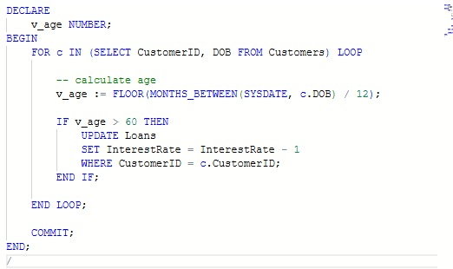
Scenario 2: A customer can be promoted to VIP status based on their balance.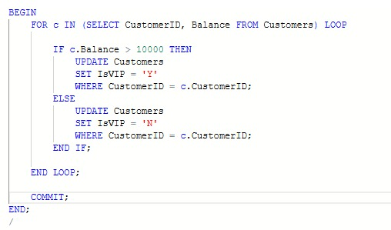
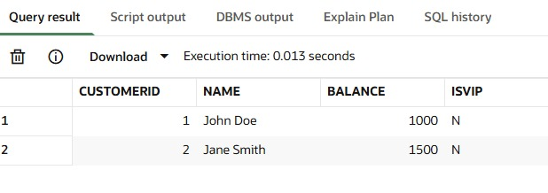
Scenario 3: The bank wants to send reminders to customers whose loans are due within the next 30 days.
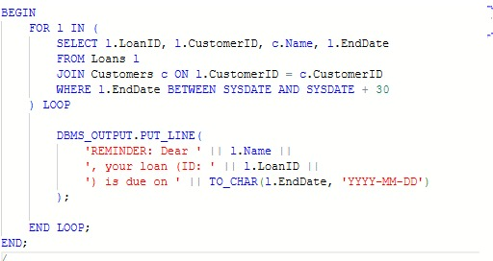
OUTPUT:
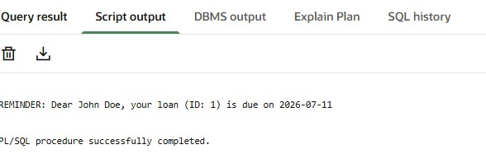

Exercise 3:Stored Procedures
Scenario 1: The bank needs to process monthly interest for all savings accounts.
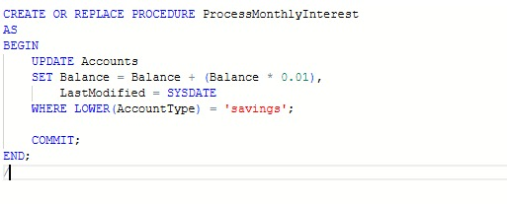
OUTPUT:
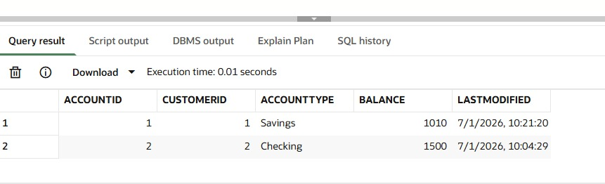
Scenario 2: The bank wants to implement a bonus scheme for employees based on their performance.
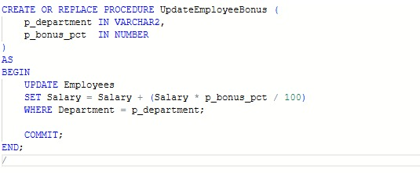
OUTPUT:
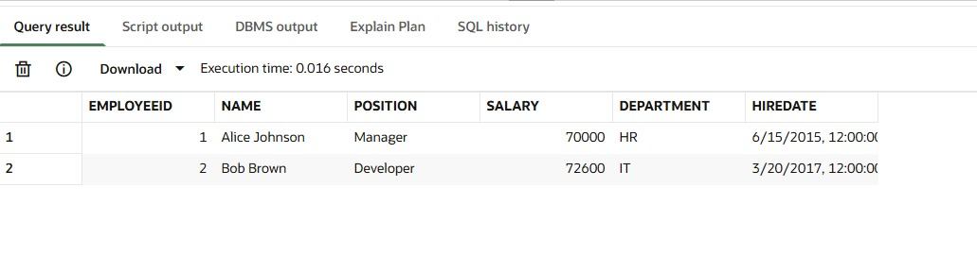
Scenario 3: Customers should be able to transfer funds between their accounts.
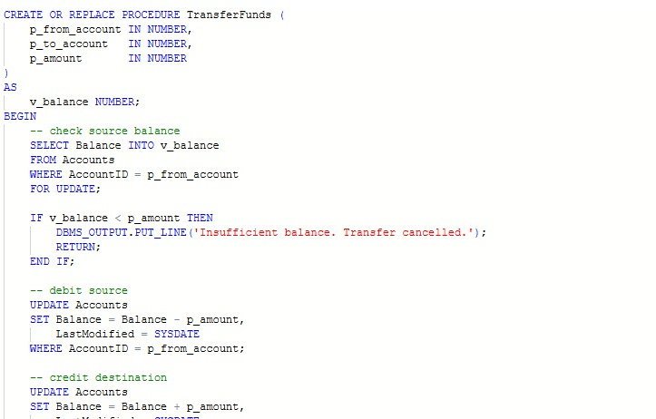
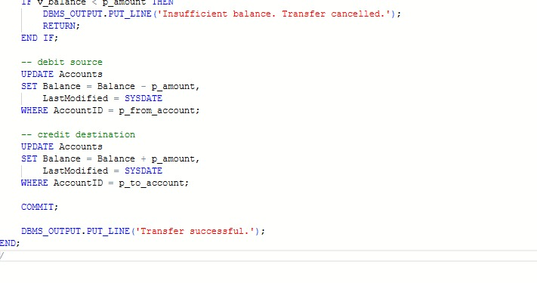
OUTPUT:
